# Comparison of Skin Wound Healing Closed with Intradermal Suture Pattern using Monofilament Poliglecaprone and Multifilament Polyglactin Sutures in Domestic Cats

**ABSTRACT**

The study was conducted to compare the skin wound healing using monofilament poliglecaprone and multifilament polyglactin sutures. Twelve apparently healthy, adult, intact female cats were equally divided into three groups (days seven, 14 and 21 post- surgery). Two full thickness midventral abdominal incision wounds were made and sutured. Macroscopically, wounds closed with monofilaments showed significantly greater scab formation (day 7 and day 14), hyperemia (day 0) and elevation (day 0 and day 7). Scar formation was significantly greater in multifilaments (day 21). None of the wounds observed showed discharge and dehiscence. Microscopically, wounds closed multifilaments were significantly invaginated and thicker (day 14 and day 21). The wound gap was only observed on day 7 while angiogenesis was consistent for the duration of the study. Neutrophils and fibroblasts were significantly greater in wounds closed with multifilaments. Most of the wound had light bacterial growth and none had heavy growth. The most common isolate was coagulase negative *Staphylococcus* spp. Single isolates were more common in wound closed with monofilaments. The mean tensile strength of multifilament polyglactin was not significantly higher that of the monofilament poliglecaprone. Furthermore, both suture materials has surpassed the values previously reported. Monofilaments were able to retain their tensile strength at day 21 post-surgery. Results show that monofilament is a better alternative to multifilament in the management of skin wounds.

Keywords: cats, healing, sutures, wounds

# INTRODUCTION

The skin is considered the largest organ (Inas and Kawkab, 2012). It is exposed to countless possible insults that commonly rise from direct trauma, such as injuries, burns, ulcers, incisions or as a result of skin disease that compromise the normal functions and structures of the skin (Yila *et al*., 2006). Wounds are defined as an injury or break in the continuity to any of the tissues of the body due to physical or mechanical (Dunn, 2005), chemical, electrical, thermal or nuclear causes. Although the body’s physiological process allows it to heal naturally, some wounds require mechanical support (Yila *et al*., 2006).

Suturing provides mechanical support where natural wound healing is not possible or delayed. It is undertaken to facilitate rapid wound closure and healing resulting to a functional and aesthetically satisfactory scar (Singer and Clark, 1999). A suture is described as any material that may be used to ligate or approximate wound edges for closure. It may be classified based on the number of filaments the material has. Monofilaments are those composed of a single strand of suture material while multifilaments are those composed of several strands twisted or braided together, where the latter is much more accepted and widely used for ease of handling and knot stability.

Although both materials are available in a hospital setting, the effects of monofilaments on intradermal closure has not been reported making monofilaments underused and wasted to expiration. Practitioners avoid using monofilaments, mostly due to anecdotal accounts of dehiscence and premature absorption that result in delayed wound healing. There are several techniques to apply sutures to approximate and facilitate wound closure and the intradermal suture pattern has been gaining popularity in recent years as an alternative to simple interrupted suture pattern (Sylvestre *et al*., 2002; Smeak, 2008). The

use of intradermal suture pattern has been considered ideal when there is a need for minimal scar tissue or when exposed, protruding sutures may irritate the patient (Archibald, 1974) and result in self-mutilation (Sylvestre *et al*., 2002).

In 2013, Chupeco *et al*. published a study on intradermal suture patterns, comparing two different anchor techniques using multifilament suture material. However, to date, studies conducted to determine the effects of monofilament and multifilament absorbable suture materials in intradermal closures are nil. The study will therefore be conducted to describe the effects of the use of the different suture materials (monofilament and multifilament) in the intradermal suture pattern. It will examine and evaluate the macroscopic and microscopic characteristics of wound healing.

# MATERIALS AND METHODS

The use of animals in this study as described in the procedure below was approved by the University of the Philippines’ College of Veterinary Medicine’s Institutional Animal Care and Use Committee (IACUC).

Twelve (12) apparently healthy, adult female, domestic short-haired cats (*Felis catus*) were used in the study. These animals were at least eight months old, but not more than two years old. The age was determined by the examination of the dental arcades following the description by Crossley (1995). These animals were acquired from an animal shelter, were housed individually and given commercial dry cat food (Royal Canin® Feline Indoor 32; Aimargues, France) twice daily following the manufacturer’s recommended daily amounts. Clean water was also provided *ad libitum*. The animals were randomly assigned into three groups (Groups A, B and C), which corresponded to the post-operative

period when wound examination and biopsy were conducted (Group A = day seven post operation; Group B = day 14 post operation; Group C = day 21 post operation).

After the two weeks’ acclimatization period, each cat underwent general physical examination. A nine-point scale, described by WSAVA and Bjornvad *et al*. (2011) was used to assess the Body Condition Score (BCS) of each animal. Routine hematologic examination and fecalysis were performed at least two days prior to surgery following the techniques as described by Coles (1986). Only cats with normal hematologic values, no parasitic ova observed, and apparently healthy were included in the study.

Each cat was fasted for at least six hours prior to surgery. The baseline heart rate (HR; beats per minute), respiratory rate (RR; breaths per minute) and rectal body temperature (RT; °C) were acquired for each animal. A balanced general anesthetic regimen composed of Atropine sulphate (Atrosite® 0.65mg/ml ampule; Ilium – Troy Laboratories Australia Pty Ltd; 0.04mg/kg body weight; subcutaneously), xylazine HCl (Ilium Xylazil – 20mg/ml; 100ml bottle; Ilium – Troy Laboratories Australia Pty Ltd; 1mg/kg body weight; intramuscular) and tiletamine-zolazepam (Zoletil® 50mg/ml; 5ml bottle; Virbac Laboratories, Carros, France; 5mg/kg body weight; intramuscular or intravenous). These drugs were administered at five minute intervals. The suitable plane of anesthesia was maintained using Isoflurane USP (Aerrane; Baxter Healthcare of Philippines, Inc., Ortigas Center, Pasig City, Philippines; 2% to 3% inhalation) administered using a mask attached to a circle system rebreathing circuit (SurgiVet; Smiths Medical PM, Inc., USA) with an Isoflurane vaporizer (VetLand Medical Sales and Services, L. L. C., Louisville, KY). Tolfenamic acid (Tolfine®; Vetoquinol, Cedex, France; 4mg/kg body weight; subcutaneous) was used as analgesic after surgery.

The ventral abdominal area was clipped and shaved using an electric clipper (Andis

® two speed clipper; Andis, Wisconsin, United States) with a carburized clipper blade (UltraEdge® Detachable blade Size 40 (0.25mm); Andis, Wisconsin, United States) from the thoracic area to the pubis. Aseptic preparation of the surgical site was done using 10% povidone iodine solution followed by 70% isopropyl alcohol. The animals were placed on dorsal recumbency and draped using the four corner draping technique. Aseptic technique was employed throughout the procedure.

Two 5.0 cm full thickness skin incisions, at least 3.8 cm apart, were made on the midventral abdominal area as described by Fossum (2014). Simple random sampling by lottery was done to assign the suture material used to close the cranial (Cr) and caudal (Cd) ventral midline incision or wound. Poliglecaprone 25 (3-0 Coated MONOCRYL™ Monofilament Suture; Ethicon US) and Polyglactin 910 (3-0 Coated Vicryl™ Braided; Ethicon US), both are absorbable with a swaged on, half circle tapered point needle were used. The skin was closed using a buried intradermal suture pattern with a pulley knot free anchor technique (Campbell, 2004). The incisions were disinfected with 10% povidone iodine antiseptic solution (Betadine®; Mundipharma Distribution GmbH, Ortigas Center, Pasig City, Philippines) and bandaged using sterile gauze and zinc oxide skin adhesive which were removed 24 hours post-surgery.

The wounds were cleaned and topical mupirocin (Bactifree® 2% Ointment; Amherst Laboratories Inc., Biñan, Laguna) was applied twice daily for the duration of the study. All cats were given meloxicam (Inflacam 1.5 mg/ml suspension; Plaridel Products and Services Inc., San Juan, Metro Manila, Philippines; 0.1 mg/kg body weight orally) once a day orally for three to five days. The animals were maintained under similar

conditions for the duration of the study. The complete apposition of the wound with minimal tissue reaction and scar formation are the desired outcomes and were noted in the study.

Macroscopic examination of the wound

The wounds were grossly examined and photo-documented on post-operative day 0, day seven (Group A), day 14 (Group B) and day 21 (Group C). The macroscopic changes were assessed and evaluated using the technique adapted from Pedrajas (2000). The wounds were examined and graded for the following: scab formation, discharge, hyperemia, elevation, dehiscence and scar formation. Photographs of the wounds were assessed blindly by three veterinarians experienced with surgery.

After the macroscopic examination of the wound on the prescribed post-operative days, the animals were placed under anesthesia using the same protocol previously described. Once sufficient plane of anesthesia was achieved, the animals were prepared for microbial sample collection, testing of the tensile strength and skin biopsy for microscopic examination.

The animals were placed on dorsal recumbency. The surgical wounds were swabbed using a commercially available transport swab (Amies charcoal transport swab; Atico Medical Pvt. Ltd., Haryana, India) following the manufacturer’s instructions in sample collection and storage recommendations. The samples were assessed for growth qualitatively and categorized as **light growth** – where growth is only observed on the first quadrant only; **moderate growth** – where the growth are observed in the first and second quadrant and **heavy growth** - where the growth are observed on the first, second and third quadrant. Routine biochemical test was done on all the isolates.

With the animal still on dorsal recumbency, the suture lines were identified. A single simple interrupted suture using silk attached to a half circle cutting needle (2-0 Tudor®; Braided Non Absorbable Suture; Tudor, USA) was placed in the middle of the suture line to divide it into the anterior and posterior wound regions. The anterior region was used to determine the tensile strength. Two loops, approximately one centimeter lateral to the suture line were placed on the skin using the same 2-0 silk suture material. The hook of a calibrated, hand held scale (Otex Model No. 600-20; Capacity 20kgs; Graduation 250gms; Japan) was placed into one of the loops while the index finger was placed on the other loop. The suture line was pulled apart until there is complete disruption of the wound. The values obtained from the scale in mass (kilograms) was recorded. Tensile strength was expressed as force with the unit Newton (N) using the formula *F = m x a*, where *m* is the mass in kilograms and *a* is the acceleration, which in this case was 9.8 m/s2.

The posterior wound region was used for the collection of skin biopsy samples for the preparation of histological slides. A 1.5 cm x 1.5 cm square, with the incision line in the middle, was identified on the posterior wound and a full thickness incision of the skin was done. Once the incision was complete, the incised skin for biopsy was gently lifted from one corner and the sample was undermined from the underlying subcutaneous tissues. Careful manipulation was done in order not to disrupt the wound apposition and the biopsy samples were placed on wooden tongue depressors and secured using commercially available metal push pins. The samples were placed in 10% buffered formalin solution and stored for at least 48 hours before routine paraffin technique.

The animals, while still under anesthesia, were humanely euthanized using a concoction of Magnesium sulfate and Potassium chloride administered intracardially. The

tissue samples were mounted and sectioned at 5 µm and stained using routine Hematoxylin and Eosin stain. The histological slides were examined using the various objectives of the compound light microscope.

The microscopic features of the wound were graded using a technique adapted from Nisbet *et al*. (2010). The tissue sections were examined for epidermal invagination, epidermal thickening, angiogenesis, wound gap, neutrophil infiltration and fibroblastic proliferation. Photomicrographs were taken using EVOS® XL Cell Imaging System ate the Molecular Biology Laboratory of the Department of Veterinary Paraclinical Sciences, College of Veterinary Medicine, UPLB and assessment was done independently and blindly by three veterinarians experienced with surgery. The following were noted for the microscopic examination of the wound using the point scale (Pedrajas, 2002; Nisbet *et al*., 2010):

The modal frequencies in the parameters for the evaluation of macroscopic and microscopic wound healing were analyzed using Mann Whitney U test with 5% degree of significance. Mann Whitney U Test is the non-parametric alternative test to the independent sample t-test. ANOVA with post-hoc Tukey’s test at 5% level of significance was used to analyze the tensile strength of the different suture materials.

# RESULTS AND DISCUSSION

Table 1 shows the summary of the mode of the different macroscopic characteristics of the wound observable for the duration of the study. These characteristics included scab formation, the presence of discharge, hyperemia, elevation of the wound, dehiscence of the suture line and the formation of a scar.

Scab formation was present in day seven (Fig. 1a) and day 14 post-operation for both suture materials. It was also observed that the greatest degree of scab formation was found in day seven of the wounds closed using the monofilament suture material. The presence of scab in such cases may indicate the presence of small or narrow gaps between the wound edges that may expose the underlying subcutis. Scabs are the residue from the initial clot on the wound which are formed for hemostasis. These aid in minimizing wound contamination, ensuring that wound healing will not be disrupted (Campbell, 2004). Its presence confirms that the body will protect itself from exposure to various environmental insults including contamination of the wound bed that may eventually lead to infection and suture failure.

The presence of scab was only observed in the early stages of wound healing and not in the later, which indicates that re-epithelization of the wound site has already closed the gap. The movement and development of the epidermal cells would be towards the wound edge, and under the scab, where these cells would later push the scab away from the newly formed epidermis. There was significantly greater scab formation in wounds closed with monofilament poliglecaprone as compared to the wounds closed with multifilaments polyglactin at day seven (p<0.05).

None of the animals used had discharge from the wound. Wound discharge may range from serous, clear discharge, to bloody and mucopurulent discharge where the latter would signify the presence of gross contamination that elicited the body to mount an antibody response (Dunn, 2005). Moreover, the presence of discharge can be associated with the amount of space left while suturing, which in this case was not observed,

suggestive that both monofilament and multifilament suture materials were equally effective in the apposition of the wound edges and minimizing dead space.

Hyperemia was observed in both wounds closed with monofilament poliglecaprone and multifilament polyglactin right after surgery (day 0) (Fig. 1b). Hyperemia or vasodilation ensures the increase of blood flow at the site of the wound, ensuring that the wound site receives the necessary nutrients and oxygen that enables the body to proceed with wound healing without any complications. Moreover, since hyperemia is associated with wound, it is also possible that it is a reaction to the trauma in the wound site. Such trauma could have been brought about by the handling of the skin during suturing. Although the monofilament poliglecaprone would have less friction during suturing than the multifilament polyglactin, the former exhibit package memory which makes handling, manipulating and suturing more difficult than the latter. This difficulty in handling and manipulation is also the reason for the increased handling of the skin by instruments, such as forceps, to ensure the application of the suture material.

Multifilaments are widely used and has no memory, the braided and/or twisted arrangement of the fibers may have added resistance while suturing, however, the degree of handling and manipulation may not be as great as that performed using the monofilament suture. Results of this study showed that the wounds closed with monofilament poliglecaprone are significantly (p<0.05) hyperemic compared to the wound closed with multifilament polyglactin immediately after surgery.

Elevation on the wound site (Table 1) is greatest during the early stages of wound healing, decreasing as the wound matures. Furthermore, a greater degree of elevation was observed in the wounds closed with monofilament poliglecaprone. This may be related to

the package memory of the suture material. Elevation may also be associated with inflammation and possibly infection, especially in cases of clean-contaminated to dirty wounds. Elevation decreases as the wound heals and matures, as the body is able to cope with the possible infection.

Elevation was found to be more pronounced in the wounds closed with monofilaments poliglecaprone, particularly at day seven, compared to those wounds closed with multifilaments polyglactin (Fig. 2a). Since no discharge was observed from the wound site during the study, the elevation could be brought about by the added suture material under the skin. The wounds were closed using an intradermal pattern with a pulley knot free anchor technique, both of which place the suture material immediately under the skin. During the study, it was observed that those with pronounced elevation, upon examination and palpation of the wound site, had firm elevations. Dead space is a post- surgical complication that becomes soft and fluid-filled, but this was not observed in this study. The firm elevations may be due to the presence of the sutures and how it is arranged under the skin, especially after using the pulley knot free anchor pattern. The memory of monofilament suture materials may have also played a role in the elevation that resulted from the possible deformation of the suture after application. Statistical analysis showed that there is significantly greater elevation in the wounds closed with monofilament poliglecaprone than the wounds closed with multifilament polyglactin at day seven (p<0.05).

Dehiscence in this study was not observed for both monofilament and multifilament absorbable suture materials for the duration of the study. This means that both monofilament and multifilament suture materials were able to aid in the undisrupted and

uncomplicated healing of the surgical wound. Dehiscence is the failure of a portion, partial or complete of a sutured wound that results in the exposure of the underlying tissues or organs. Dehiscence can be the result of a faulty suture technique, suture material or suture pattern. The improper proportion of the suture size and the tissue or skin to be sutured has also been identified as a cause of dehiscence. The suture technique employed in this study was intradermal suture pattern with a pulley knot free anchor technique, where the sutures were placed as close to the wound edge as possible underneath the skin. The aim of this pattern is to ensure apposition of the wound edges while ensuring that no suture material is exposed that may be the nidus for infection or a point for traumatic injuries to happen.

Scar formation was evident at day 14 for both suture materials and greatest at day 21 (Fig. 2b) for the multifilament. According to Baker *et al*. (2009), scar is a dermal fibrous replacement tissue. It is brought about by fibrosis, as a response to injury or wounds. Scars replace tissues that has undergone fibrosis in the attempt to close a wound. Ideally, surgical wound should present minimal scarring. Moreover, the intradermal suture pattern, which has been used in humans in cosmetic surgical procedures, results in minimal scar formation. There are no significant differences in the scar formation between wounds closed with monofilament suture materials and multifilament suture materials at days 14 and 21 (p<0.05).

Microscopic Characteristics

The tissue sections closed with monofilament and multifilament absorbable suture materials are shown in Figs. 3a and 3b.

Epidermal invagination (Fig. 4) was observed in both monofilament and multifilament suture materials as presented in Table 2. Furthermore, invagination was more pronounced in the early stages of wound healing (day 7) and found to be decreasing as the wound matures. It was also observed that multifilaments, across the treatment groups showed severe epidermal invagination. The higher degree of epidermal invagination during the early stages of wound healing could be brought about the early epidermal bridging. This is consistent with the findings of Chupeco *et al*. (2013). On the other hand, the higher degree of invagination observed in multifilaments could be brought about the trauma and misalignment that may be related to the increased friction during suturing. In an attempt to protect itself from contamination and infection, the body will try to bridge the gap between wound edges. During the proliferative phase, the bordering epithelium wound extends over the ends of the dermis resulting in a dermal-epidermal junction, which may be seen as invaginations microscopically. Statistical analysis showed that the wound closed with multifilament polyglactin sutures had significantly invaginated epidermal layer than those closed with monofilament poliglecaprone sutures (p<0.05) at days 14 and 21.

Similar to that of epidermal invagination, epidermal thickening (Fig. 4) also showed to be increased during the early stages of wound healing, which gradually decreases as the wound matures. During the proliferative phase of wound healing, the epidermal cells undergo an increased mitotic activity, resulting on the advancement of the epidermis, to cover the wound that is now covered with the scab. This is a continuous attempt of the body to protect itself. The increased mitotic activity, according to Ritte (2016), extends into the adjacent normal epidermis, which can be observed as epidermal thickening.

Moreover, much more severe epidermal thickening was found in day seven with the wound sutured with multifilaments. Such findings show that regardless of the suture material used, both invagination and thickening can be observed, with a more severe observation in multifilaments. For epidermal thickening, statistical analysis showed that the wound closed with multifilament polyglactin sutures had significantly thickened epidermal layer than those closed with monofilament poliglecaprone sutures (p<0.05) at days 14 and 21.

Angiogenesis was present in all the animals in the study (Fig. 4). Moreover, the degree of angiogenesis was found to be similar for both monofilament and multifilament suture materials. Angiogenesis is the physiologic response of the body to ensure sufficient blood flow to the wound that transports nutrients, oxygen, neutrophils and macrophages which are essential in wound healing. This is often seen as the proliferation of new blood vessels and may also be increased during inflammation and conditions related to wounds (Nagy *et al*., 2008). The lower reading consistent for the duration of the study suggest that the wounds were healing with no complication or infection, hence, minimal angiogenesis was needed. For angiogenesis, there were no significant difference between wounds closed with monofilament poliglecaprone and multifilament polyglactin sutures (p<0.05).

Although none of the animals experienced gross dehiscence of the surgical site, wound gaps were found on day seven post-surgery for both monofilament poliglecaprone and multifilament polyglactin suture. There were no statistical significant difference in the wound gap at day seven (p<0.05) between these wounds. Thereafter, no wound gaps were observed.

Table 2 shows that the presence of neutrophils was observed for the duration of the study, with the greatest number observed on day seven, which eventually decreased as the

wound matured. Inflammation is the body’s local response to injury and wounds. This is marked by the presence of various cells, but most notable would be the presence of neutrophils and macrophages, which initiate, remove and dissolve noxious agents, damaged and devitalized tissues. For this study, the presence of neutrophils was considered to indicate inflammation. Although the procedure employed in this study was performed and maintained aseptically, the presence of neutrophils was still observed. The location where these cells were found were crucial as most of them were not found on the wound edges but instead were mostly found were the suture materials were placed.

The presence of neutrophils were noted to be different for both wounds closed with monofilament poliglecaprone (Fig. 5a) and multifilament polyglactin (Fig. 5b) sutures, where there were significantly less in the former compared to the latter. Furthermore, a decreasing trend in the number of neutrophils was found in the wound sutured with monofilaments while the wound sutured with multifilaments maintained a high number of neutrophils throughout the observation period. Suture materials are considered foreign bodies and are made of inert materials that will mount a minimal host reaction. The presence of neutrophils in this study then could be attributed to the presence of suture materials and the technique employed in closing the wounds. Unlike in the simple interrupted pattern where the amount of suture material embedded under the skin is shorter, the intradermal suture pattern is a continuous pattern that embeds the suture under the skin, in the subcutis.

The actual difference in the suture material, between monofilaments and multifilaments may have also an effect on the amount of neutrophils observed in the tissue biopsy. Monofilaments are sutures composed of a single strand of material while

multifilaments are those with multiple strands arranged as braided or twisted. The simplicity of the structure of the former prevents contamination of the suture material. Moreover, its simple structure allows the suturing with minimal resistances as the material passes through the skin in the intradermal pattern. The presence of multiple strands in multifilaments increases the possibility of contamination and adds friction and resistance during suturing. Most of the neutrophils in the multifilament sutures can be observed around the border of the suture material and the individual strands which are arranged as braided. Monofilaments on the other hand, maintain the neutrophils at the periphery of the suture material in the tissue biopsy. Statistical analysis showed that the neutrophils present in the wounds closed with multifilament polyglactin was significantly greater (p<0.05) than those found in the wounds closed with monofilament poliglecaprone for the duration of the study.

Fibroblasts were found to be present in all the animals for the duration of the study. Moreover, the amount of fibroblasts was found to be greater in the wounds closed using multifilament (Fig. 5b) suture materials, which is indicative of proliferative phase. Fibroblasts are cells that are necessary in the contraction and healing of wounds. The presence of these cells, along with collagen, will facilitate and add structural integrity. The increased amount of fibroblasts suggests that multifilament suture materials may have been more traumatic compared to monofilaments. Furthermore, the pattern by which the suture is applied may also have an effect on the presence of fibroblasts. Similar to neutrophil infiltration, statistical analysis for the presence of fibroblasts showed that there was a significantly greater (p<0.05) amount of fibroblasts in the wounds closed with

multifilament polyglactin sutures than those closed with monofilament poliglecaprone sutures for the duration of the study.

Microbial Profile

All treatment groups had light growth in at least one animal per group. Light growth was also observed for the duration of the study for both monofilament and multifilament. A wound, if not promptly treated and managed properly, may lead to invasion of both pathogenic and non-pathogenic bacterial microflora. Table 3 shows the qualitative microbial growth analysis of the wound closed by monofilament and multifilament suture materials. Despite the efforts of making the procedure aseptic, there is still possible postoperative contamination. This could be the reason for such observation. The number of animals with no growth was higher in monofilaments (5/12) than in multifilaments (2/12), suggesting that the wound is free from either pathogenic or non- pathogenic bacterial flora. Monofilaments, because of the simple structure, prevents fluid accumulation, which may become a medium for bacterial growth. On the other hand, there were more wounds closed with multifilaments that has at least light and moderate growth.

None of the wounds had heavy growth.

Table 4 shows the type of bacteria isolated from the samples collected from the wounds closed by monofilament and multifilament suture materials. There were five types of bacteria isolated from wound from both monofilament and multifilament, except for *Enterobacter cloacae*, which was not isolated in any of the 12 wounds swabbed from the wounds closed with monofilament suture material. Coagulase negative *Staphylococcus* was the most common isolate identified in three and eight of the 12 wounds swabbed for

both monofilament and multifilament suture material, respectively. Knowing the presence of bacteria in the wound site is important, especially in non-healing wounds. Equally important is the isolation and biochemical identification of these bacteria that will allow practitioners to come up with appropriate treatment and preventive measures.

*Staphylococcus* is the most common pathogen in both man and animals (Quinn *et al*., 2009). Both Coagulase negative *Staphylococcus* and *Staphylococcus saphrophyticus* were among the isolates. The presence of these non-pathogenic Staphylococcus may be attributed to disturbances in the host defense mechanism, including surgery (Quinn *et al*., 2009; Frykberg and Banks, 2015). Despite being non-pathogenic, its presence, if not properly managed, may prolong wound healing. And although Staphylococcal infections are usually regarded as pyogenic (Quinn *et al*., 2009), none of the samples exhibited mucopurulent discharges.

Other isolates include *Enterobacter cloacae*, *Enterobacter aerogenes* and *Achromobacter* sp. These are opportunistic pathogens that inhabit the gastrointestinal tract, but are known to be widely distributed throughout the environment (Quinn *et al*., 2009). It is possible that the animals used in this study contaminated the wound by licking and grooming. Most infections are taken as nosocomial or involving immunocompromised patients. *Achromobacter* sp. has been associated with cats with inflammatory polyps and respiratory infections.

Table 5 summarizes the frequency distribution of single and multiple isolates for wounds that were positive for bacterial isolation. Five of the seven wounds closed with monofilaments are single isolates, while the other two have multiple isolates. This trend is different from the wounds closed with multifilament suture materials, where a higher

number of the wounds (7/10) had multiple isolates. Although the suture material is not directly in contact with the external environment, it can assumed that the trauma was brought about by the multifilament suture material. It can also be assumed that stress, including pain, may have caused a slight immune depression in these animals that may have resulted in the proliferation of these opportunistic bacterial organisms. Immune depression leads to the animal’s susceptibility to bacterial infection and proliferation, which was observed in this study.

Another possible reason for having such results was the possibility of contamination of the suture materials before and during suturing. Such contamination may come from any of the members of the surgical team, the surgical environment, instruments and equipment and the patient itself. The simplicity of the gross appearance of the monofilament poliglecaprone ensures minimal contamination, as compared to that of the multifilament polyglactin. The complex structure and braided appearance of the multifilament polyglactin may present micro spaces and areas where microorganisms may proliferate. Further contamination of the suture materials was kept to a minimum since the suture pattern used in this study was intradermal, a pattern that ensures that the suture materials will have no contact to the external environment.

Tensile Strength

Table 6 shows the tensile strength of the wounds closed with monofilament poliglecaprone and multifilament polyglactin sutures for the duration of the study. The multifilament suture material has proven superior tensile strength over the monofilaments, having retained 73.02% of its tensile strength at day 21 of the study. The tensile strength

of the suture material should be uniform and consistent as weakness and inconsistencies in its tensile strength may lead to suture material failure and dehiscence, which was not observed in this study. Although the tensile strength of the suture material per se is important, retaining this strength once exposed to the wound and its condition is more important. The early stages of wound healing would solely rely on the tensile strength of the suture material until the skin has fully healed. According to literature, the suture should have lost 50% of its tensile strength three weeks post-surgery, which was not the case in this study. Furthermore, the loss of tensile strength in multifilaments are gradual.

Monofilaments, on the other hand, retained 47.54% tensile strength at day 21, which surpassed previous study’s findings of complete loss of such strength at the same period. The trend by which monofilaments lose tensile strength may not be as gradual as with the multifilament having lost more than 50% of its tensile strength at day 14. Statistical analysis (p<0.05) showed that the wound closed with multifilament polyglactin sutures required a stronger force, at day 14, to disrupt wound healing as compared to the monofilament poliglecaprone. Nonetheless, the use of monofilament suture materials are comparable to that of multifilaments.

The results of this study will provide useful information on the cutaneous or intradermal tissue reaction to monofilament and multifilament absorbable suture material. The information gathered will aid veterinary surgeons as to the choice of the suture material that can be used in wound closure. The results may also be used to modify the supply procurement of veterinary hospitals and clinics with regards to suture materials, so as to prevent wastage and loss to expiration. If found equally effective and useful, the study will pave the way for maximizing the use of monofilament suture materials in wound closure

as an alternative to what has been commonly used in veterinary practice which are multifilaments.

# ACKNOWLEDGEMENT

The author wishes to extend his warmest gratitude to the National Research Council Philippines for the financial assistance in the conduct of this study. My sincerest gratitude to those who significantly contributed in this study. Thank you very much.

# LITERATURE CITED

Archibald J. 1974. *Canine Surgery*. 2nd ed. California: American Veterinary Publications Inc. pp.

35-50.

Baker R, Urso-Baiarda F, Linge C and Grobbelaar A. 2009. Cutaneous scarring: a clinical review.

*Dermatology and Research Practice* 2009: 1-7.

Bjornvad CR, Nielsen DH, Armstrong PJ, Mcevoy F, Hoelmkjaer KM, Jensen KS, Pedersen GF and Kristensen AT. 2011. Evaluation of a nine-point body condition scoring system in physically inactive pet cats. *American Journal of Veterinary Research* 72(4): 433- 437.

Campbell BG. 2004. Pulley knot-free suture pattern. *Proceedings: The North American Veterinary Conference*. Orlando, Florida, p. 1148.

Campbell J. 2007. *Campbell’s Pathophysiology Notes*. England: Lorimer Publications.

Chupeco JPM, Flores MLS and Reyes MF. 2013. Macroscopic and microscopic changes in the wound after intradermal closure using buried knot and pulley knot-free patterns following ovariectomy in cats. *Philippine Journal of Veterinary and Animal Science* 39 (2): 277 – 286.

Crossley DA. 1995. Tooth enamel thickness in the mature dentition of domestic dogs and cats – preliminary study. *Journal of Veterinary Dentistry* 12: 111–113.

Dunn DL (ed.) 2005. *Ethicon Wound Closure Manual*. Somerville, New Jersey: Ethicon Inc. pp.

2-17.

Fossum TW. 2014. *Small Animal Surgery*. 4th ed. Missouri: Mosby Elsevier. pp. 57-75.

Frykberg RG and Banks J. 2015. Challenges in the treatment of chronic wounds. *Advances in Wound Care* 4(9): 560-582. DOI: 10. 1089/wound.2015.0635. Date accessed: 25 April

2018.

Inas NEH and Kawkab AA. 2012. Application of chitosan for wound repair in dogs. *Life Science Journal* 9 (1): 196-203.

Nagy JA, Benjamin L, Zeng H, Dvorak AM and Dvorak HF. 2008. Vascular permeability, vascular hyperpermeability and angiogenesis. *Angiogenesis* (2008) 11: 109-119.

Nisbet HO, Nisbet C, Yarum M, Guler A and Ozak A. 2010. Effects of three types of honey on cutaneous wound healing. *Wounds* 22(11): 275-283.

Pedrajas AG. 2002. Comparison of the effects of a modified continuous intradermal closure and simple interrupted pattern on healing of experimental ventral abdominal skin incisions in cats. *Undergraduate Thesis*. College of Veterinary Medicine, University of the Philippines Los Baños.

Quinn PJ, Carter ME, Markey B and Carter GR. 2009. Clinical Veterinary Microbiology. St.

Loiuse: Mosby.

Rittie L. 2016. Cellular mechanisms of skin repair in humans and other mammals. *Journal of Cell Communication and Signaling* (2016) 10: 103-120.

Singer AJ and Clark RAF. 1999. Cutaneous wound healing. *New England Journal of Medicine*

341 (10): 738-746.

Slyvestre A, Wilson J and Hare J. 2002. A comparison of 2 different suture patterns for skin closure of canine ovariohysterectomy. *Canadian Veterinary Journal* 43: 699-702.

Smeak DD. 2008. BCID: How to bury the final knot. *Proceedings: European Veterinary Conference.* Amsterdam, Netherlands, pp. 209-210.

Yila SA, Adawa DAY, Hassan AZ, Jahun BM, Ogunkoya AB and Ihejirika KA. 2006. The wound healing effects of some topical antiseptic creams in dogs. *Journal of Animal and Veterinary Advances* 5 (12): 1067-1072.

# TABLES

Table 1. Comparison of macroscopic characteristic grade (mode) of the wound healing between monofilament poliglecaprone (MNP) and multifilament polyglactin (MTP) sutures in the domestic cat.

|  |  |  |  |  |  |  |  |  |
| --- | --- | --- | --- | --- | --- | --- | --- | --- |
| PARAMETER | DAY 0 (n = 4) | | DAY 7 (n = 4) | | DAY 14 (n = 4) | | DAY 21 (n = 4) | |
|  | MNP | MTP | MNP | MTP | MNP | MTP | MNP | MTP |
| Scab | 0a  (0-1) | 0 a  (0-2) | 2 a  (1-2) | 1b  (1-2) | 0 a  (0-1) | 1 b  (1) | 0 a  (0) | 0 a  (0) |
| Discharge | 0 a  (0) | 0 a  (0) | 0 a  (0) | 0 a  (0) | 0 a  (0) | 0 a  (0) | 0 a  (0) | 0 a  (0) |
| Hyperemia | 3 a  (2-3) | 2 b  (1-2) | 0 a  (0) | 0 a  (0) | 0 a  (0) | 0 a  (0) | 0 a  (0) | 0 a  (0) |
| Elevation | 3 a  (1-3) | 2 a  (1-3) | 2 a  (1-2) | 1 b  (1-2) | 0 a  (0) | 1 a  (1-2) | 0 a  (0) | 0 a  (0) |
| Dehiscence | 0 a  (0) | 0 a  (0) | 0 a  (0) | 0 a  (0) | 0 a  (0) | 0 a  (0) | 0 a  (0) | 0 a  (0) |
| Scar formation | 0 a  (0) | 0 a  (0) | 0 a  (0) | 0 a  (0) | 0 a  (0-1) | 1 b  (1) | 0 a  (0) | 2 b  (1-2) |

Modes with different superscripts among rows are different (P<0.05).

Table 2. Comparison of microscopic characteristic grade (mode) of the wound healing between monofilament poliglecaprone (MNP) and multifilament polyglactin (MTP) sutures in the domestic cat.

|  |  |  |  |  |  |  |
| --- | --- | --- | --- | --- | --- | --- |
| PARAMETER | DAY 7 (n =4) | | DAY 14 (n = 4) | | DAY 21 (n = 4) | |
|  | MNP | MTP | MNP | MTP | MNP | MTP |
| Epidermal Invagination | 2 a  (2-3) | 3 a  (2-3) | 1 a  (1-2) | 2 b  (2-3) | 0 a  (0-1) | 1 b  (1) |
| Epidermal Thickening | 2 a  (2-3) | 3 a  (2-3) | 0 a  (0-1) | 1 b  (1-2) | 0 a  (0-1) | 1 b  (1-2) |
| Angiogenesis | 1 a  (1) | 1 a  (1) | 1 a  (1) | 1 a  (1) | 1 a  (1) | 1 a  (1-2) |
| Wound gap | 1 a  (0-2) | 1 a  (0-1) | 0 a  (0) | 0 a  (0) | 0 a  (0) | 0 a  (0) |
| Neutrophil infiltration | 2 a  (1-2) | 3 b  (2-3) | 1 a  (0-2) | 3 b  (2-3) | 1 a  (1) | 3 b  (2-3) |
| Fibroblasts proliferation | 1 a  (1-2) | 3 b  (2-3) | 1 a  (0-2) | 3 b  (2-3) | 1 a  (0-1) | 3 b  (1-3) |

Modes with different superscripts among rows are different (P<0.05).

Table 3. Frequency distribution of qualitative microbial growth analysis of skin swabs of the wounds closed using monofilament poliglecaprone (MNP) and multifilament polyglactin (MTP) sutures in the domestic cat.

|  |  |  |  |  |  |  |  |  |
| --- | --- | --- | --- | --- | --- | --- | --- | --- |
| GROWTH TYPE | DAY 7 (n = 4) | | DAY 14 (n = 4) | | DAY 21 (n = 4) | | TOTAL (n = 12) | |
|  | MNP | MTP | MNP | MTP | MNP | MTP | MNP | MTP |
| No growth | 1 | 0 | 3 | 2 | 1 | 0 | 5 | 2 |
| Light growth | 3 | 3 | 1 | 1 | 2 | 4 | 6 | 8 |
| Moderate growth | 0 | 1 | 0 | 1 | 1 | 0 | 1 | 2 |
| Heavy growth | 0 | 0 | 0 | 0 | 0 | 0 | 0 | 0 |

Legend: Light growth – growth observed on the first quadrant only; Moderate growth – growth observed on the first and second quadrant; Heavy – growth on the first, second and third quadrant.

Table 4. Frequency distribution of isolated bacteria from surgical wounds closed using monofilament poliglecaprone (MNP) and multifilament polyglactin (MTP) sutures in the domestic cat.

|  |  |  |
| --- | --- | --- |
| BACTERIA | MNP (n = 12) | MTP (n = 12) |
| Coagulase negative *Staphylococcus* | 3 | 8 |
| *Enterobacter cloacae* | 0 | 3 |
| *Enterobacter aerogenes* | 2 | 1 |
| *Staphylococcus saphrophyticus* | 1 | 1 |
| *Achromobacter* sp. | 2 | 4 |

Table 5. Frequency distribution of the number of organisms (single or multiple) isolated from the surgical wounds closed using monofilament poliglecaprone (MNP) and multifilament polyglactin (MTP) sutures in the domestic cat.

|  |  |  |  |  |
| --- | --- | --- | --- | --- |
| TYPE OF ISOLATE | MNP  (n =  7) | IDENTIFIED ISOLATES | MTP  (n  =10) | IDENTIFIED ISOLATES |
| Single isolate | 5 | *Enterobacter aerogenes* (2);  *Staphylococcus saphrophyticus* (2); Coagulase negative *Staphylococcus*  (1) | 3 | *Staphylococcus saphrophyticus* (1); Coagulase negative *Staphylococcus* (1);  *Enterobacter aerogenes* (1) |
| Multiple isolates | 2 | Coagulase negative *Staphylococcus*  & *Achromobacter* sp. (2) | 7 | Coagulase negative *Staphylococcus* & *Enterobacter cloacae* (3); Coagulase negative *Staphylococcus* & *Achromobacter* sp. (4) |

Table 6. Mean ± SD tensile strength (N = Newton) of the sound closed with monofilament poliglecaprone (MNP) and multifilament polyglactin (MTP) sutures at day 7, 14 and 21 post operation.

|  |  |  |  |  |
| --- | --- | --- | --- | --- |
| GROUP | DAY 0 (n = 4) | DAY 7 (n = 4) | DAY 14 (n = 4) | DAY 21 (n = 4) |
| MNP | 37.36 a ± 3.182 | 26.34 a ± 9.700 | 18.38 a ± 2.739 | 17.76 a ± 2.031 |
| MTP | 38.59 a ± 1.060 | 33.08 a ± 6.600 | 31.24 b ± 8.009 | 28.18 a ± 9.248 |

Means with different superscripts among columns are different (P<0.05).

# FIGURES

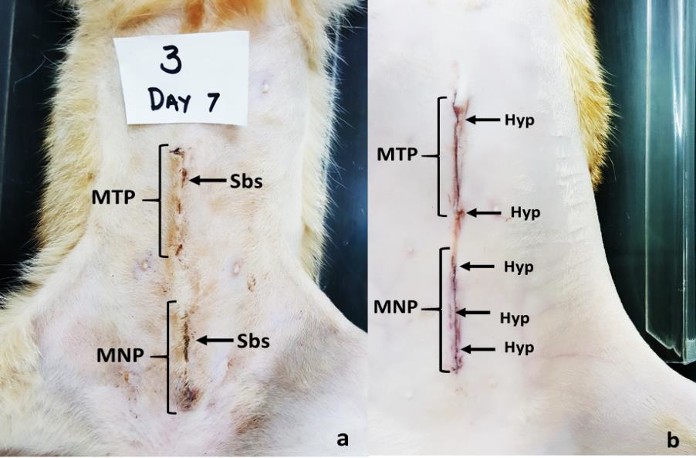

Figure 1a. The midventral abdominal skin incisions at day seven post-surgery showing the presence of scabs (Sbs) for both wounds closed with monofilament poliglecaprone (MNP) and multifilament polyglactin (MTP) suture materials in the domestic cat.

Figure 1b. The midventral abdominal skin incisions right after suturing at day 0 showing hyperemia (Hyp) in both wounds closed with monofilament poliglecaprone (MNP) and multifilament polyglactin (MTP) sutures in the domestic cat.

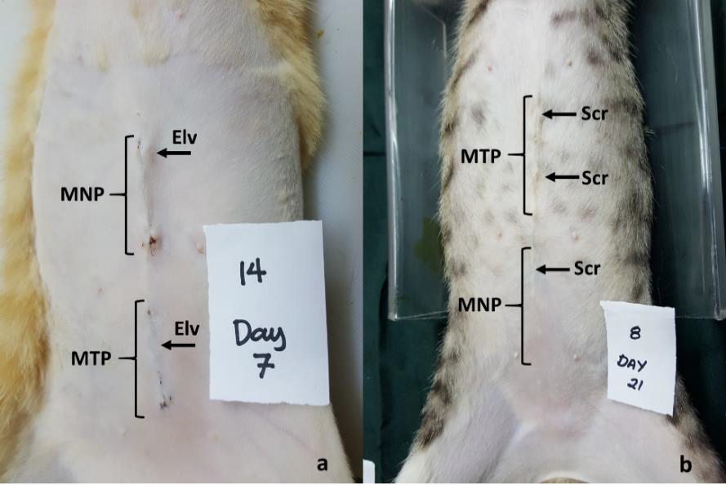

Figure 2a. The midventral abdominal skin incisions at day seven post-surgery showing the elevation (Elv) of the surgical site for both wounds closed with monofilament poliglecaprone (MNP) and multifilament polyglactin (MTP) sutures in the domestic cat.

Figure 2b. The midventral abdominal skin incisions at day 21 post-surgery showing scar (Scr) formation which more evident in wounds closed with multifilament polyglactin (MTP) than monofilament poliglecaprone (MNP) sutures in the domestic cat. Note the absence of a visible scar in the second figure.

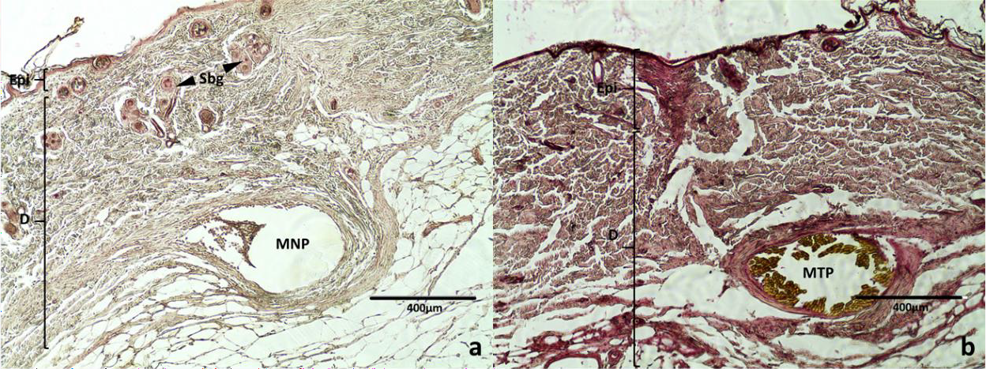

Figure 3a. Histological features of the wound showing the epidermis (Epi), dermis (D), sebaceous glands (Sbg) and the monofilament poliglecaprone (MNP) suture used to close the wound using the intradermal pattern at day 14. H & E stain.

Figure 3b. Histological features of the wound showing the epidermis (Epi), dermis (D), and the multifilament polyglactin (MTP) absorbable suture material used to close the wound using the intradermal pattern at day 14. H & E stain.

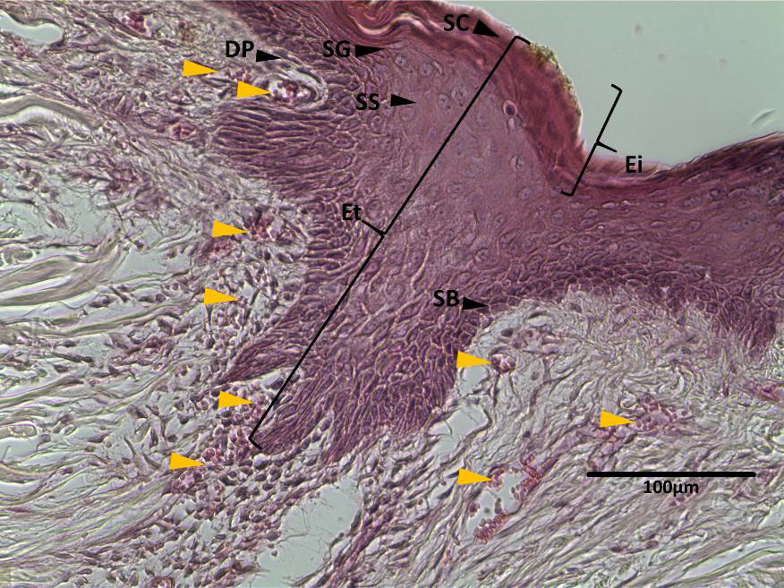

Figure 4. Histological features of the wound showing epidermal thickening (Et), epidermal invagination (Ei), stratum corneum (SC), stratum granulosum (SG), blood vessel (BV), stratum spongiosum (SS), stratum basale (SB) and dermal papillae (DP). The section is also showing angiogenesis of the wound demonstrated by the presence of multiple blood vessels marked by the orange arrows at day 7. H & E stain.

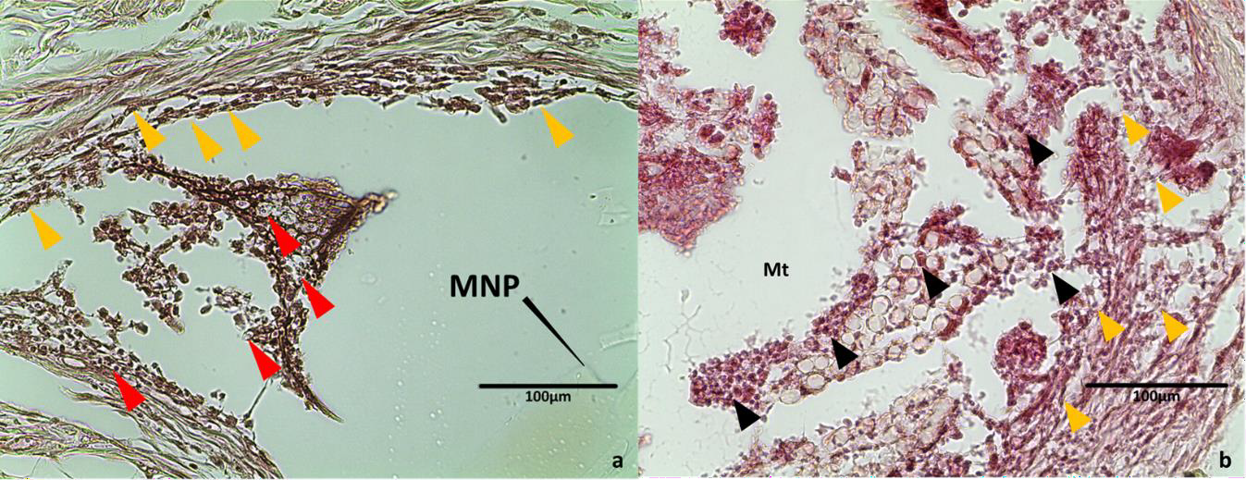

Figure 5a. Histological features of the wound closed with monofilament poliglecaprone (MNP) suture using the intradermal pattern showing the presence of neutrophils (red arrowhead) and fibroblasts (orange arrowheads) located at the periphery of the suture material at day 14. H & E stain.

Figure 5b. Histological features of the wound closed with multifilament polyglactin (MTP) suture using the intradermal pattern showing the presence of neutrophils (black arrowhead) and fibroblasts (orange arrowheads) located at the periphery and braided fibers of the suture material at day 14. H & E stain.